H
Practical 1: Introduction to Canva

- Digital Marketing Course Promotional Poster
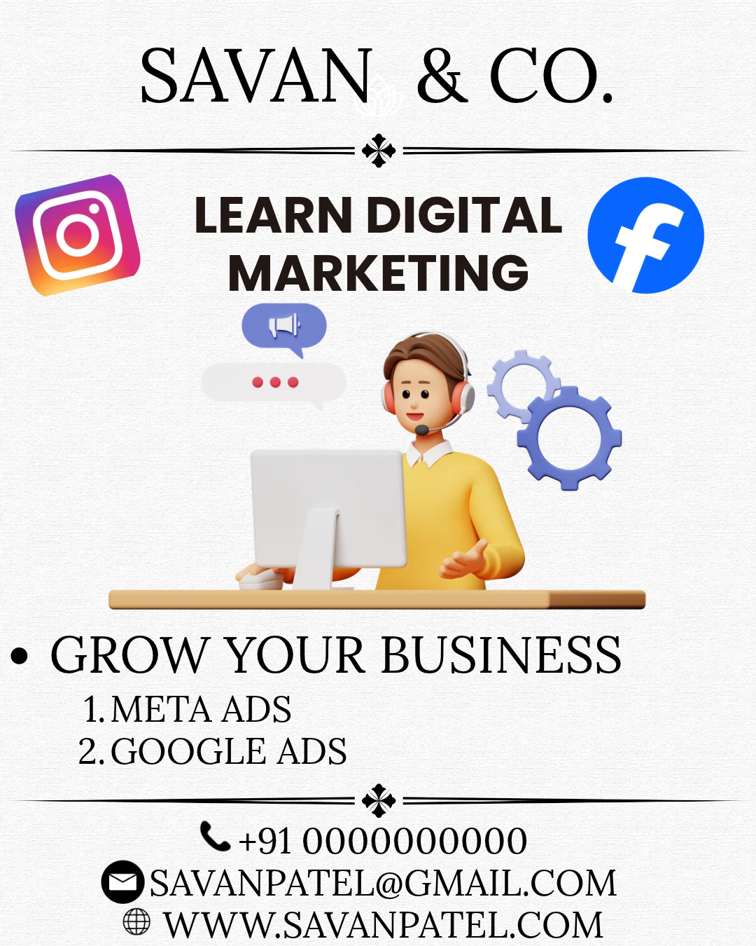

- YouTube Thumbnail for Digital Marketing
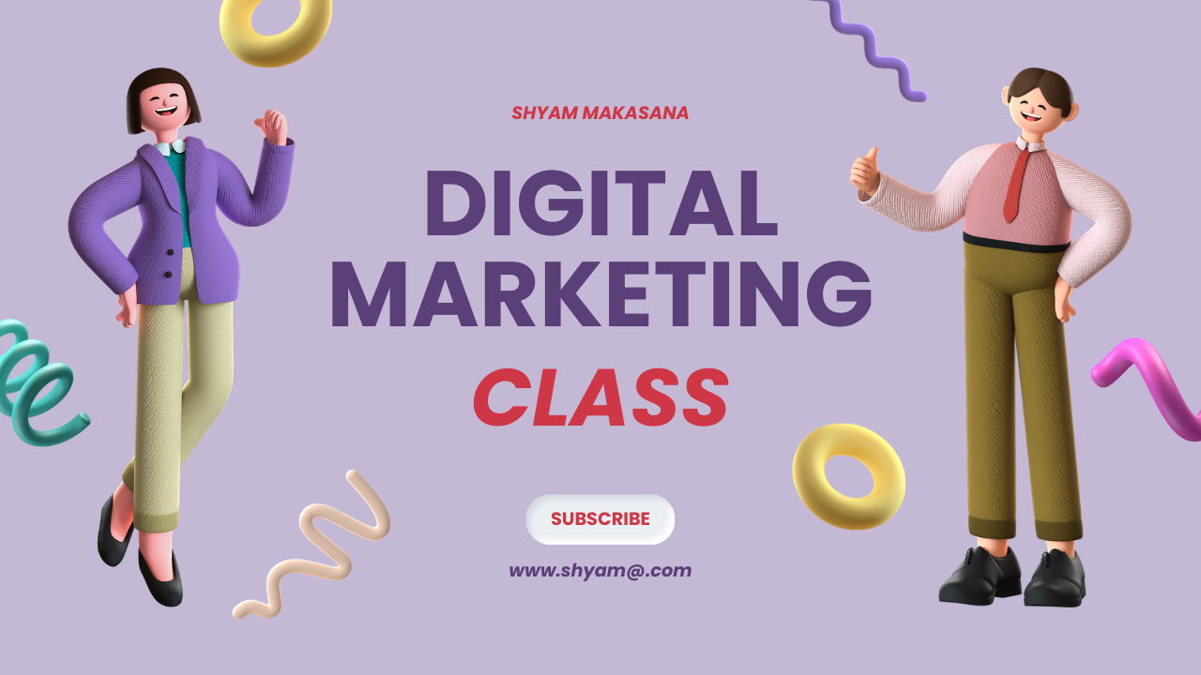


- Solar Energy Advertisement Design

Practical 2: Infographic Design Using Canva

E-Commerce Growth in India Cyber Security Do’s and Don’ts
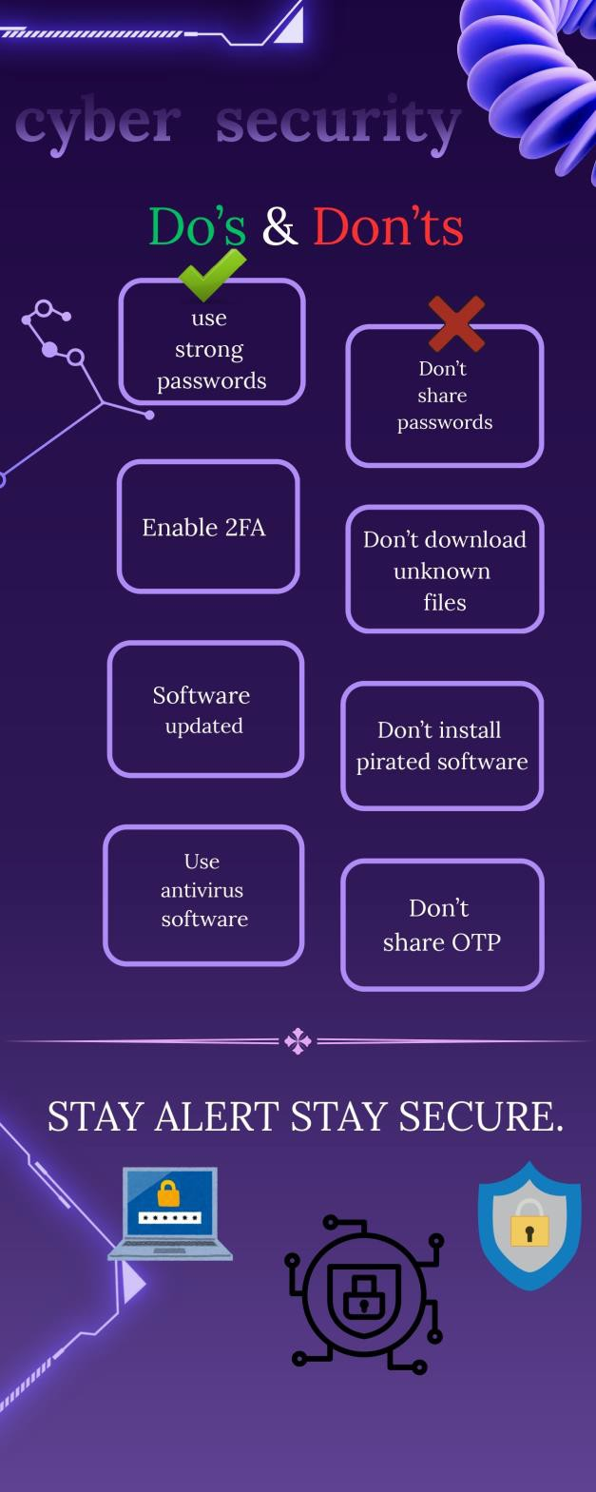


Practical 3: Content Calendar & AI Tools
Day | Week | Content Pillar | Post Type | Visual/Hook Idea | AI-Generated Caption | Relevant Hashtags
 |  | Behind-the-Scenes & |  | Visual: 15-sec cinematic floor tour.Hook: "Rajkot, | Ready to upgrade your routine? Fitness Factory Gym is officially here to level up your gains! Clean machines, expert trainers, and unmatched vibes. Drop | #FitnessFactoryRajkot #RajkotGym
1 | W1 | Culture | Reel | welcome to your new fitness home!" | a in the comments if you’re working out today! | #RajkotFitness #GymsInRajkot #FitRajkot
 |  | Educational & How- |  |  | New to the gym? Don't stress the gym lingo! Swipe through to learn what sets, reps, supersets, and macro splits actually mean. Save this post for your | #GymTipsForBeginners #FitnessEducation
2 | W1 | To | Carousel | Visual: "5 Gym Terms Every Beginner Should Know." | next workout! | #Rajkot #GujaratFitness #WorkoutTips
3 | W1 | Relatable & Local Humor | Story | Visual: Interactive poll: "Did you hit the gym today or make excuses?" | No judgment here... but your gains are waiting! Click YES if you’re stepping on the gym floor today. | #RajkotDiaries #RajkotCity #GymMotivation #Rajkot
 |  |  |  |  | Hitting your protein targets on a pure veg diet in Rajkot isn't impossible! Paneer, sprouts, sattu, and | #GujaratiFitness #VegProtein
4 | W1 | Educational & How-To | Image | Visual: Graphic: High-protein vegetarian foods available in local Rajkot markets. | curd are your best friends. Which one is your daily go-to? | #RajkotFoodies #HealthyRajkot #FitnessFactory
 |  | Transformation & |  | Visual: Trainer intro video.Hook: "Meet Coach Jay: 5 | Meet Coach Jay! From posture correction to intense fat-loss plans, he’s guided over 200+ members. Want a custom workout plan? DM us 'COACH' to get started | #RajkotTrainer #PersonalTrainerRajkot
5 | W1 | Social Proof | Reel | years of transforming Rajkot’s desk job routines." | today! | #FitnessGoals #FitGujarat
 |  |  |  |  | Thinking about joining but want to try us out first? Experience Rajkot’s best workout vibe completely free for 3 days! Link in bio to claim your pass before slots | #RajkotGyms #GymOfferRajkot
6 | W1 | Promotional & Offers | Image | Visual: Bold poster: "Claim Your Free 3-Day Trial Pass!" | fill up! | #RajkotLife #FitnessFactoryRajkot
 |  | Relatable & Local |  | Visual: Skit: "Eating Farsan on Sunday vs. Leg Day on | We all love Sunday snacks, but Monday always collects the tax! Drop a if you're sweating off | #RajkotMemes #Rajkotian #GymHumor
7 | W1 | Humor | Reel | Monday." | those weekend meals today! | #FitnessMemes #Rajkot
 |  | Educational & How- |  | Visual: Side-by-side comparison.Hook: "Stop doing Lat | Arc your back too much on lat pulldowns? You're missing the lats and straining your lower back. Watch | #FormFix #WorkoutTips #GymMotivation
8 | W2 | To | Reel | Pulldowns like this!" | how Coach Jay fixes form in 10 seconds! | #RajkotGym #FitIndia
 |  | Behind-the-Scenes & |  |  | Peak evening vibe at Fitness Factory! High energy, great music, zero excuses. Come smash your evening | #RajkotFitness #GymVibes
9 | W2 | Culture | Story | Visual: Video clip of clean equipment + upbeat audio. | session! | #FitnessFactory
 |  | Relatable & Local |  | Visual: Meme: "Me explaining to my mom why 4 eggs a | The ultimate daily struggle in every Gujarati household! Tag a friend whose mom says the | #GujaratiMemes #Rajkot #FitnessHumor
10 | W2 | Humor | Image | day won't heat up my body." | exact same thing! | #DesiGym #RajkotCity
 |  |  |  |  | Weight loss doesn't mean eating plain boiled food! Rahul balanced home-cooked Gujarati dinners with | #RajkotTransformations
11 | W2 | Transformation & Social Proof | Carousel | Visual: Client spotlight: "How Rahul lost 8kg in 60 days without giving up home food." | structured lifting at Fitness Factory. Swipe to see his progress! | #WeightLossRajkot #FitRajkot #FitnessFactoryRajkot
 |  | Educational & How- |  | Visual: Graphic: "Desk Worker Special: 3 Stretches for | Sitting in an office chair for 8+ hours in Rajkot? Undo stiff hips and back pain with these 3 daily stretches. | #OfficeFitness #BackPainRelief
12 | W2 | To | Image | Lower Back Pain." | Do these right at your desk! | #RajkotProfessionals #HealthyLifestyle
 |  |  |  | Visual: Direct Link Sticker: "Book Your Free Fitness | Wondering where your body fat & muscle mass stand? Tap the link to book a FREE Body
13 | W2 | Promotional & Offers | Story | Assessment." | Composition Analysis at our gym this week! | #RajkotGym #GymOffer #FitRajkot
14 | W2 | Behind-the-Scenes & Culture | Reel | Visual: Montage of members high-fiving & working out. Hook: "The friendliest gym culture in Rajkot." | Gym anxiety holding you back? At Fitness Factory,  everyone starts somewhere and everybody cheers you on. Walk in as a beginner, walk out as family! | #GymCommunity #RajkotDiaries #FitnessFactory #RajkotGyms
15 | W3 | Educational & How-To | Carousel | Visual: "How to Structure Your First Workout Week." | Feeling overwhelmed on where to start? Here is a  simple, effective 3-day split designed specifically for gym beginners. Tap save & get to work! | #WorkoutRoutine #BeginnerGym #FitnessTips #Rajkot #FitGujarat
16 | W3 | Relatable & Local Humor | Reel | Visual: POV: "Trying to walk down stairs after heavy squat day." | Escalators at the mall never looked so attractive!  Drop a comment if leg day turned your legs into jelly this week! | #LegDay #GymHumor #Rajkot #Rajkotians #FitMemes
17 | W3 | Transformation & Social Proof | Story | Visual: Reposting a tagged story from a member’s workout. | Love seeing our members smash their PRs! Tag us in your gym stories to get featured on our page! | #FitnessFactoryRajkot #MemberSpotlight #Rajkot
18 | W3 | Promotional & Offers | Image | Visual: Banner graphic: "Student Offer: Flat 15% Off with College ID." | Studying hard? Sweat harder! Show your college ID at  the Fitness Factory front desk and unlock an exclusive student discount on quarterly plans! | #RajkotStudents #MarwadiUniversity #AtmiyaUniversity #RKUniversity #DarshanUniversity
19 | W3 | Educational & How-To | Reel | Visual: Demo video.Hook: "Are you bench pressing with flat shoulders?" | Retract your scapula! Retracting your shoulder blades  protects your joints and targets your chest muscles properly. Watch Coach demonstrate! | #BenchPress #ChestWorkout #GymTips #RajkotGym #FitIndia
20 | W3 | Behind-the-Scenes & Culture | Story | Visual: Q&A Sticker: "Ask us anything about weight loss & muscle gain!" | Got fitness questions? Our head coach is answering everything live in our stories today! Drop your questions below! | #FitnessQnA #Rajkot #GymCoach
21 | W3 | Relatable & Local Humor | Image | Visual: Photo: Gym shaker placed next to a traditional tea glass. | Morning Kathiyawadi Chai vs. Pre-workout shake: Why not both? What fuels your workout routine?  Let us know in the comments! | #RajkotCulture #ChaiLovers #GymLife #Rajkot #FitRajkot
22 | W4 | Educational & How-To | Carousel | Visual: "5 Reasons Why You’re Not Losing Weight (And How to Fix It)." | Working hard in the gym but the scale isn't moving? You might be falling for these 5 common mistakes. Swipe left to troubleshoot your fat loss! | #FatLossTips #WeightLossJourney #RajkotFitness #FitGujarat
23 | W4 | Transformation & Social Proof | Reel | Visual: Member interview clip.Hook: "I lost 12kg without skipping family dinners in Rajkot." | Meet Priya! She balanced family functions, festival food, and work with our custom fitness coaching. Hear her advice for beginners! | #TransformationTuesday #RajkotWomen #FitWomenRajkot #FitnessFactory
24 | W4 | Behind-the-Scenes & Culture | Story | Visual: Video showing equipment maintenance & daily deep cleaning. | Cleanliness comes first! We deep clean every machine daily so you can train in a safe, pristine environment. | #CleanGym #GymHygiene #FitnessFactoryRajkot
25 | W4 | Educational & How-To | Reel | Visual: Tutorial video.Hook: "3 ways to use the cable machine for toned arms." | Cable machines are super versatile! Here are 3 simple  isolation moves you can add to your arm routine today. Try them out! | #ArmWorkout #CableMachine #GymGuide #RajkotGym
26 | W4 | Promotional & Offers | Image | Visual: Sleek graphic: "Bring a Buddy Week: Train Free Together!" | Workouts are better with your best friend! Current  members can bring a workout buddy for FREE all of this week. Tag your gym partner! | #GymBuddy #RajkotFitness #WorkoutTogether #FitnessFactory
27 | W4 | Relatable & Local Humor | Story | Visual: Poll: "Morning 6 AM Workout vs. Evening 7 PM Workout?" | Are you an early bird or an evening warrior? Cast your vote and let's see which squad dominates our gym!  Free weights or selectorized machines? The short answer: both! Swipe to read when you should use dumbbells vs. machines for best results.  High energy, heavy weight, zero noise. Start your mornings right at Fitness Factory Rajkot! What time are you hitting the gym today?  Time is ticking! Grab our discounted 3-month membership before rates go back to standard. Tap link to reserve your spot!  Slouching over a laptop all day? Here are 4 targeted movements to fix neck strain and rounded shoulders. Save this post for work!  Hard work + structured overload = real results. Check  out Amit's strength and muscle transformation! Want to build muscle? DM 'GAINS' today. | #Rajkot #GymPoll #FitnessFactoryRajkot
28 | W4 | Educational & How-To | Image | Visual: Infographic: "Dumbbells vs. Machines: Which is better for fat loss?" |  | #GymKnowledge #FitnessFacts #Rajkot #FitIndia
29 | W4 | Transformation & Social Proof | Reel | Visual: Cinematic montage of morning weightlifting sessions. |  | #MorningWorkout #RajkotFitness #GymMotivation #FitnessFactory
30 | W4 | Promotional & Offers | Story | Visual: Countdown Sticker: "Only 5 Spots Left for Special Monthly Rate!" |  | #RajkotGyms #GymDiscount #Rajkot
31 | W5 | Educational & How-To | Carousel | Visual: "4 Posture Fixes for Tech Workers & Desk Drivers." |  | #PostureCorrection #RajkotIT #OfficeHealth #FitRajkot
32 | W5 | Transformation & Social Proof | Reel | Visual: Before/After slider video.Hook: "How Amit gained 6kg of lean muscle in 90 days." |  | #MuscleGain #RajkotTransformations #FitRajkot #FitnessFactoryRajkot
33  34  35  36 | W5  W5  W5  W5 | Relatable & Local Humor  Educational & How-To  Behind-the-Scenes & Culture  Promotional & Offers | Story  Image  Reel  Image | Visual: Quiz Sticker: "Guess the exercise by its description!"  Visual: Graphic: "Pre-Workout vs. Post-Workout Meals Explained."  Visual: Fast-paced fun edit.Hook: "What Rajkot trainers actually do during break time."  Visual: Offer Poster: "Corporate Group Membership Plan." | Think you know your workout moves? Test your gym knowledge on our story quiz today!  Fueling your body correctly makes all the difference! Here is what to eat before hitting the gym for energy, and after for muscle recovery.  From quick arm pumps to testing out new smoothie recipes, our coaches stay busy! Drop a comment on who your favorite trainer is!  Fitness is better with co-workers! Get up to 20% off  when 3 or more colleagues sign up together from your office. Tag your co-workers below! | #GymTrivia #Rajkot #FitnessFactory  #NutritionTips #PreWorkout #PostWorkout #RajkotFitness  #GymCulture #TrainerLife #RajkotDiaries #FitnessFactory  #RajkotCorporate #RajkotBusiness #RajkotJobs #FitnessFactoryRajkot
37  38  39  40  41 | W5  W6  W6 W6  W6 | Relatable & Local Humor  Educational & How-To  Transformation & Social Proof  Behind-the-Scenes & Culture  Relatable & Local Humor | Story  Reel  Image Story  Reel | Visual: Meme repost: "When you finish cardio and check if you have a six-pack yet."  Visual: Corrective demo.Hook: "Stop doing Romanian Deadlifts like a regular Deadlift!"  Visual: Photo of female member doing lat pulldowns. Hook: "Lifting weights won't make women bulky!"  Visual: Video snippet of cardio floor during peak hours.  Visual: Skit: "Me resisting street food on Race Course Road." | Looking in the mirror right after 10 minutes on the treadmill like... Who else is guilty of this?  Soft bend in the knees, push your hips backward! Master the hip hinge to target your hamstrings and glutes without hurting your lower back.  Busting the biggest myth in fitness! Weight training helps women burn fat, tone up, and build confidence. Join our thriving female fitness community today!  Calorie burning in full swing tonight! Have you completed your cardio session today?  Walking past food stalls after a heavy workout takes ultimate willpower! Who relates to this Rajkot  struggle? Tag a friend! | #GymMemes #FitnessHumor #Rajkot  #RDL #LegDay #FormFix #RajkotGym #FitIndia  #WomenWhoLift #FitWomenRajkot #RajkotGirls #FitnessFactory  #CardioVibes #RajkotFitness #FitnessFactoryRajkot  #RaceCourseRajkot #RajkotFoodie #GymLife #RajkotMemes
42 | W6 | Educational & How-To | Carousel | Visual: "5 Simple Habits to Burn 300 Extra Calories Daily." | Fat loss isn't just about gym hours! Increasing your  daily steps and daily activity makes a huge difference. Swipe to learn 5 easy habits! | #FatLossHacks #NEAT #HealthyHabits #Rajkot
43 | W6 | Promotional & Offers | Story | Visual: Direct Link: "Claim 1 Free Personal Training Session." | Want hands-on guidance on the gym floor? Tap the  link to claim a complimentary 1-on-1 coaching session with our lead trainer this weekend! | #PersonalTrainer #RajkotOffer #FitnessFactory
44  45  46  47 | W6  W7  W7 W7 | Behind-the-Scenes & Culture  Educational & How-To  Transformation & Social Proof  Relatable & Local Humor | Image  Carousel  Reel Story | Visual: Staff photo: "The faces behind Fitness Factory Rajkot."  Visual: "Upper Body Workout Split for Busy Professionals."  Visual: Member spotlight montage.Hook: "How 50-year-old Mr. Vyas reversed knee pain with weight training."  Visual: Slider Sticker: "Rate your muscle soreness today (1-10)." | Always here to spot you, guide your form, and keep you motivated! Say hi to our certified team next time you walk in!  Only have 45 minutes to train after work? Save this efficient upper-body routine designed to maximize muscle stimulus in minimal time!  Age is just a number! Structured strength training helped Mr. Vyas rebuild leg strength and live pain-free. It's never too late to start!  Hit leg day yesterday? Slide the bar to show how much pain your legs are in today! | #RajkotGym #GymTeam #RajkotFitness #FitnessFactory  #BusyLifestyle #QuickWorkout #RajkotProfessionals #GymTips  #ActiveAging #FitnessMotivation #RajkotDiaries #FitnessFactory  #LegDayPain #Rajkot #FitnessFactoryRajkot
48 | W7 | Educational & How-To | Image | Visual: Visual guide: "How much water should you drink while working out?" | Dehydration causes early fatigue and muscle cramps!  Swipe through for a quick guide on staying hydrated during summer workouts in Rajkot. | #Hydration #SummerFitness #RajkotHealth #GymTips
49 | W7 | Promotional & Offers | Reel | Visual: Action clip.Hook: "Want 1 Month Free? Here's How!" | Refer a friend to Fitness Factory this month and get 1 extra month added to your membership completely free! Unlimited referrals allowed!  Clean locker rooms, secure storage, and hot showers ready after your session. We take care of every detail so you train hassle-free!  Which one are you? 1. The Heavy Grunter 2. The Mirror Selfie King 3. The 10-Minute Rest Talker. Drop your type in the comments!  Stop swinging your elbows! Keep your elbows pinned to your sides to place tension directly on your biceps. Watch Coach demonstrate the fix!  "Best atmosphere, clean equipment, and supportive  trainers in Rajkot!" Thank you for the love! Read more reviews on Google! | #GymReferral #RajkotGym #FreeMembership #FitnessFactoryRajkot
50 | W7 | Behind-the-Scenes & Culture | Story | Visual: Video showcasing clean locker rooms, showers, and steam facility. |  | #GymAmenities #RajkotGyms #FitnessFactory
51 | W8 | Relatable & Local Humor | Carousel | Visual: "Types of People You See at Rajkot Gyms." |  | #GymTypes #RajkotHumor #Rajkot #GymLife
52 | W8 | Educational & How-To | Reel | Visual: Tutorial video.Hook: "Fix your Bicep Curl form in 5 seconds!" |  | #BicepCurl #ArmDay #WorkoutForm #RajkotGym
53 | W8 | Transformation & Social Proof | Story | Visual: Photo: Google Review screenshot from a happy member. |  | #RajkotReviews #GoogleReview #FitnessFactoryRajkot
54 | W8 | Educational & How-To | Image | Visual: Infographic: "Sleep vs. Fat Loss: The Missing Piece." | Sleeping less than 6 hours? Poor sleep spikes stress  hormones and increases cravings. Here is why rest days are just as important as gym days! | #SleepAndFitness #Recovery #RajkotHealth #FitIndia
55 | W8 | Behind-the-Scenes & Culture | Reel | Visual: High-energy edit.Hook: "Night Shift Squad: 8 PM workout energy hit different!" | Post-work stress? Leave it on the gym floor! Join the evening crowd and blow off steam at Fitness Factory. | #EveningWorkout #RajkotNightlife #Rajkot #FitnessFactory
56 | W8 | Promotional & Offers | Image | Visual: Poster graphic: "Couple Membership Sale: Fit Together!" | Couples that train together, stay together! Sign up with  your spouse or partner this week and save 20% on annual memberships! | #CouplesWhoLift #RajkotCouples #GymOffer #FitnessFactoryRajkot
57  58  59  60 | W8  W9  W9  W9 | Relatable & Local Humor  Educational & How-To  Transformation & Social Proof  Promotional & Offers | Story  Carousel  Reel  Story | Visual: Poll: "Have you taken your protein shake today?"  Visual: "3 Core Exercises Better Than Crunches for ABS."  Visual: Transformation story.Hook: "How College Student Harsh gained confidence through weight training."  Visual: Direct Link Sticker: "Claim 3-Day Free Trial Pass." | Quick reminder to hit your daily target! Click YES if you’ve had your protein shake today!  Stop ruining your neck with hundreds of regular crunches! Try planks, hanging leg raises, and ab wheel rollouts for real core strength.  Harsh went from underweight and shy to strong and confident in just 4 months. Fitness changes more than just your physique!  Month is ending, but your fitness goals are just  starting! Tap the link to grab your free pass and start tomorrow! | #ProteinCheck #GymPoll #Rajkot  #AbsWorkout #CoreStrength #RajkotFitness #GymTips  #StudentTransformation #RajkotYouth #FitRajkot #FitnessFactory  #RajkotGym #GymTrial #FitnessFactoryRajkot
61 | W9 | Educational & How-To | Image | Visual: Guide: "What to Eat Before a Heavy Leg Day." | Don't train on an empty tank! Here are 3 fast-digesting  carb sources to consume 45 minutes before leg day for maximum energy. | #LegDayFuel #WorkoutNutrition #Rajkot #FitGujarat
62 | W9 | Behind-the-Scenes & Culture | Reel | Visual: Hype video of members deadlifting & squatting. | Sound ON Pure dedication, heavy iron, and  supportive energy. This is what training at Fitness Factory Rajkot looks like! | #GymHype #PowerliftingRajkot #FitnessFactory #RajkotGyms
63  64  65 | W9  W10  W10 | Relatable & Local Humor  Educational & How-To  Transformation & Social Proof | Story  Carousel  Reel | Visual: Meme: "Me trying to put on a shirt after Arm Day."  Visual: "5 Dumbbell-Only Exercises for Full Body Muscle."  Visual: Video montage.Hook: "30 Days of Consistency at Fitness Factory Rajkot!" | The pump is real, but taking off a tight shirt afterward is an extreme sport! Who else feels this?  No open machines? No problem! Save this full-body workout routine you can complete using just a single pair of dumbbells.  What happens when you don't miss a single workout  for 30 days straight? Watch this transformation unfold! Consistency always wins. | #ArmDayPump #GymMemes #Rajkot  #DumbbellWorkout #FullBodyRoutine #RajkotGym #GymTips  #Consistency #RajkotTransformations #FitRajkot #FitnessFactory
66  67  68  69 | W10  W10  W10 W10 | Relatable & Local Humor  Promotional & Offers  Educational & How-To  Behind-the-Scenes & Culture | Image  Story  Reel Image | Visual: Text graphic: "I don't need therapy, I just need 1 hour at the gym."  Visual: Countdown timer: "Flash Sale Ends in 24 Hours!"  Visual: Technique fix.Hook: "Are Shoulder Presses hurting your joints?"  Visual: Photo of morning cardio group smiling. | Iron therapy is real! Leave your workday stress at the door and crush your goals. Who's training tonight?  Last chance to lock in 20% OFF our 6-month membership plan! Tap link in bio to register before midnight!  Flaring your elbows straight out to the side puts unnecessary strain on your rotator cuff. Tuck them slightly inward at a 45-degree angle!  The 6 AM cardio squad bringing high energy to kick off the day! What time do you prefer to train? | #GymTherapy #MentalHealth #Rajkot #FitnessFactoryRajkot  #GymSale #RajkotOffer #FitnessFactory  #ShoulderPress #FormCheck #RajkotFitness #FitIndia  #MorningSquad #RajkotGyms #FitnessFactoryRajkot
70  71  72  73 | W10  W11  W11  W11 | Relatable & Local Humor  Educational & How-To  Transformation & Social Proof  Promotional & Offers | Story  Carousel  Reel  Image | Visual: Poll: "Did you hit your step goal today? (Yes / Working on it)"  Visual: "How to Prevent Muscle Soreness After Heavy Workouts."  Visual: Client quote overlay video.Hook: "How Personal Training changed my workout routine."  Visual: High-contrast graphic: "Pay for 6 Months, Get 1 Month FREE!" | Keep moving! Cast your vote and track your daily activity progress on our story today!  Experiencing intense DOMS after training? Swipe left to learn 4 simple recovery steps: active recovery, protein intake, hydration, and sleep.  "Having a dedicated trainer kept me accountable every single week." Hear how custom coaching accelerated results for this member!  Transform your physique before the season ends! Get  1 extra month FREE when you enroll in our 6-month plan this week. DM 'SEVEN' to grab it! | #StepCount #ActiveLifestyle #Rajkot  #MuscleRecovery #DOMS #GymKnowledge #Rajkot  #PersonalTrainerRajkot #Rajkot #FitnessFactory #FitGujarat  #GymOfferRajkot #RajkotGym #FitnessFactoryRajkot
74 | W11 | Behind-the-Scenes & Culture | Story | Visual: Sneak peek video of new gym equipment arrival. | New gear unboxing! We are constantly upgrading  facilities to give you Rajkot’s best workout experience. Come try it out today! | #NewEquipment #GymUpgrade #FitnessFactory
75 | W11 | Relatable & Local Humor | Reel | Visual: Humor skit.Hook: "When you spot your gym bro lifting heavy across the room." | Hyping up your gym partner is a mandatory duty!  Tag your gym bro who always gives you that extra push! | #GymBro #GymHumor #RajkotMemes #FitnessFactory
76 | W11 | Educational & How-To | Image | Visual: Graphic: "Creatine 101: Myths vs. Facts." | Does creatine cause hair loss? Is it safe for  beginners? We are breaking down facts vs. myths backed by science. Swipe to read! | #Creatine #SupplementTips #RajkotFitness #FitIndia
77 | W11 | Promotional & Offers | Story | Visual: Link sticker: "DM 'FIT' for Free Trial Pass." | Want to experience our gym facility this weekend?  Send us a DM with 'FIT' and we'll send your instant free pass! | #RajkotGym #FreePass #FitnessFactory
78  79  80  81 | W12  W12  W12 W12 | Educational & How-To  Transformation & Social Proof  Behind-the-Scenes & Culture  Relatable & Local Humor | Carousel  Reel  Story Image | Visual: "5 Simple Habits for Fat Loss Success."  Visual: Fast compilation of transformations.Hook: "90 Days. 50+ Real Rajkot Transformations!"  Visual: Photo: Trainer team holding a weekly planning session.  Visual: Meme: "My brain at 6 AM: Stay in bed. My gains: Get up!" | Long-term fat loss comes down to repeatable daily habits! Swipe through for 5 sustainable daily steps to keep fat off for good.  From weight loss to muscle gain, our members put in the work over the last 90 days. Are you ready to be our next success story?  Constantly learning and building better workout programs for our members. Quality coaching always comes first!  The internal battle every morning! What side wins for you? Drop an emoji below! vs | #FatLossHabits #WeightLoss #RajkotHealth #FitnessTips  #RajkotTransformations #Results #FitRajkot #FitnessFactory  #GymTeam #ProfessionalCoaching #Rajkot  #MorningMotivation #GymMemes #RajkotLife #FitnessFactory
82 | W12 | Educational & How-To | Reel | Visual: Demo video.Hook: "Master the Lat Pulldown for a wider back." | Drive your elbows down toward your hip pockets  rather than pulling with your arms! Watch Coach break down proper back engagement. | #BackWorkout #FormFix #GymGuide #RajkotGym
83  84  85 | W12  W12 W12 | Promotional & Offers  Behind-the-Scenes & Culture  Transformation & Social Proof | Story  Carousel Story | Visual: Direct link: "Book Your 90-Day Body Transformation Plan."  Visual: "Gym Etiquette 101: 5 Rules Every Member Should Follow."  Visual: Reposting member progress story. | Stop delaying your fitness goals! Tap link to consult with our trainers and start your custom transformation plan today!  Re-rack your weights, wipe down equipment after use, and respect space! Swipe through for basic gym etiquette guidelines.  Inspiring work! Our members are crushing their personal records this week! Tag us to get featured! | #TransformNow #Rajkot #FitnessFactoryRajkot  #GymEtiquette #GymRules #RajkotFitness #FitnessFactory  #MemberSpotlight #FitRajkot #FitnessFactory
86 | W12 | Relatable & Local Humor | Reel | Visual: Skit: "When you finally hit your target weight!" | Nothing beats the feeling of seeing your hard work pay off! Drop a if you're working toward a goal  this month! | #GoalCrushed #WeightLossSuccess #RajkotMemes #FitnessFactory
87 | W12 | Educational & How-To | Image | Visual: Graphic: "How to Keep Workouts Consistent During Travel." | Going out of town? Keep your momentum going with  this simple 15-minute bodyweight routine you can do anywhere! | #TravelWorkout #BodyweightExercise #Rajkot #FitIndia
88  89  90 | W12 W12  W12 | Promotional & Offers  Relatable & Local Humor  Transformation & Social Proof | Reel Story  Carousel | Visual: Cinematic summary edit.Hook: "Ready to transform? Annual Pass Flash Sale!"  Visual: Poll: "Are you training today or resting?"  Visual: High-impact poster: "Your 90-Day Transformation Starts Today!" | This is your sign to take action! Grab our 1-Year Annual Pass at our lowest rate of the season. Offer valid for the next 48 hours only!  Rest days are just as important as training days! Let us know what your plan is today! vs  90 days ago, our members decided to make a change. Today, they are stronger, fitter, and healthier. Now it's your turn. Drop a comment or DM us 'JOIN' to  start your journey at Fitness Factory Gym Rajkot! | #AnnualPass #GymSaleRajkot #RajkotOffer #FitnessFactoryRajkot  #GymPoll #RestDay #Rajkot  #FitnessFactoryRajkot #RajkotGym #RajkotFitness #FitGujarat #TransformToday

Practical 4: Video Editing
Topic of Video :=
The topic of the video is Product Advertisement and Promotion. The main purpose of the video is to promote a product by presenting its features, benefits, appearance, and uses in an attractive and engaging way. The video includes product shots, text animations, transitions, background music, and a call-to-action such as “Buy Now” or “Shop Now.” The video is designed to be suitable for social media platforms such as Instagram, YouTube, and Facebook.
Tools Used to Edit Video :=
The video can be edited using CapCut, Canva, Adobe Premiere Pro, or DaVinci Resolve. These tools are used to trim and arrange clips, add transitions, text, effects, background music, voice-over, subtitles, and colour adjustments.
AI Tools Used to Generate Videos :=
AI tools can be used to create video clips, product scenes, backgrounds, animations, voice-overs, and other creative elements. Tools such as Runway, Kling AI, Pika, Canva AI, and Adobe Firefly can generate or enhance video content using text prompts. AI helps save time and makes it easier to create professional-looking promotional scenes.
Stock Video – Licence-Free Sources :=
Stock videos can be obtained from websites such as Pexels, Pixabay, and Mixkit. These platforms provide free stock footage that can be used for backgrounds, lifestyle scenes, product environments, and other supporting visuals. Before using any stock video, its current licence and usage conditions should be checked, especially for commercial projects.
Description :=
For this practical, a short product advertisement video is created by combining original or AI-generated product visuals with suitable stock footage. The clips are arranged in a logical sequence, enhanced with transitions, text animations, music, and voice-over. The final video presents the product clearly and attractively while maintaining a professional advertising style. AI tools are used to generate creative visuals, while video-editing software is used for the final editing and presentation. The completed video is exported in a suitable format and resolution for online promotion.

Practical 5: Social Media Business Setup
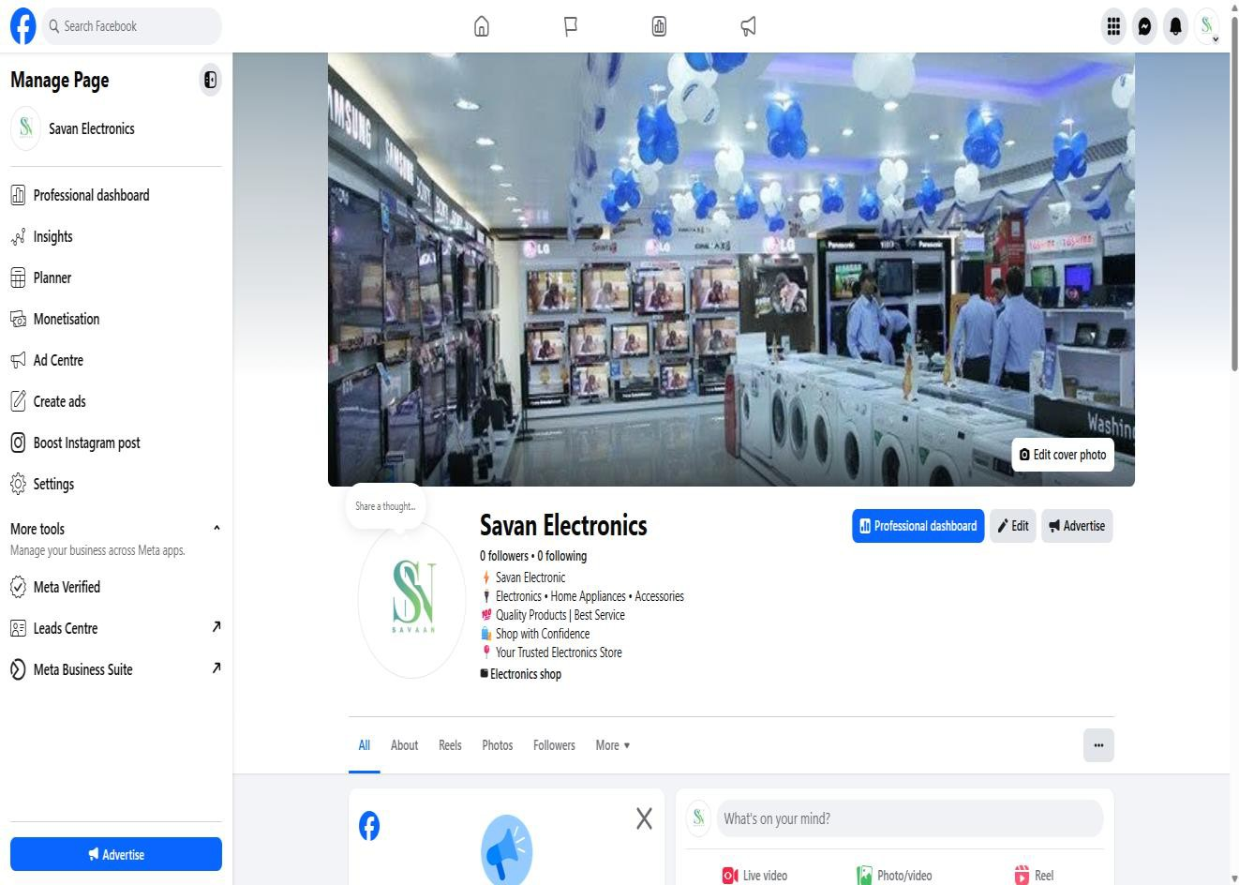
- Facebook Page :

- Meta Business Profile :
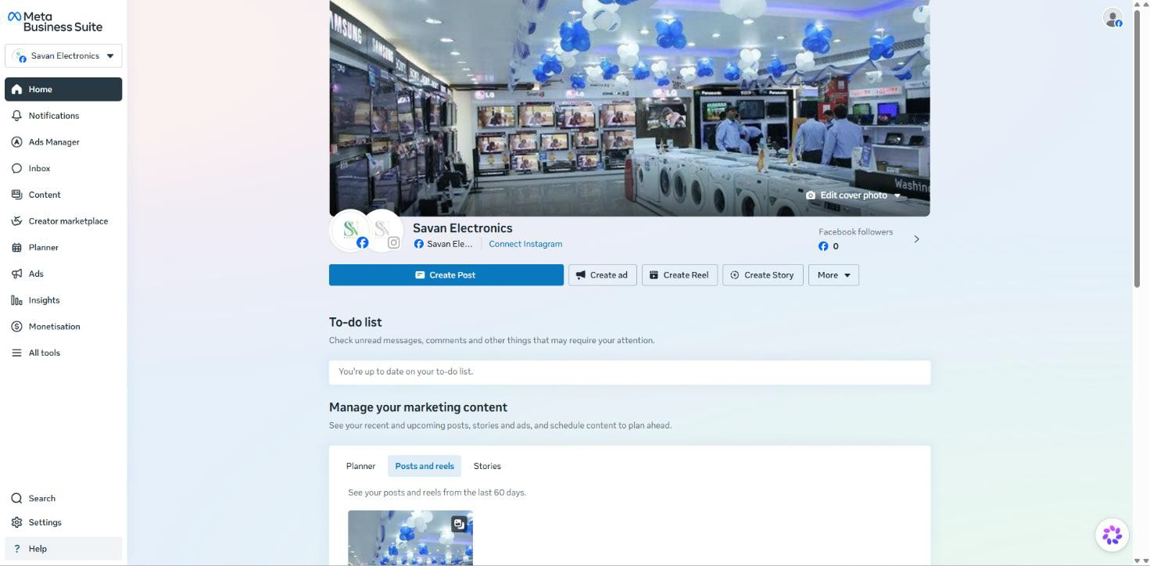

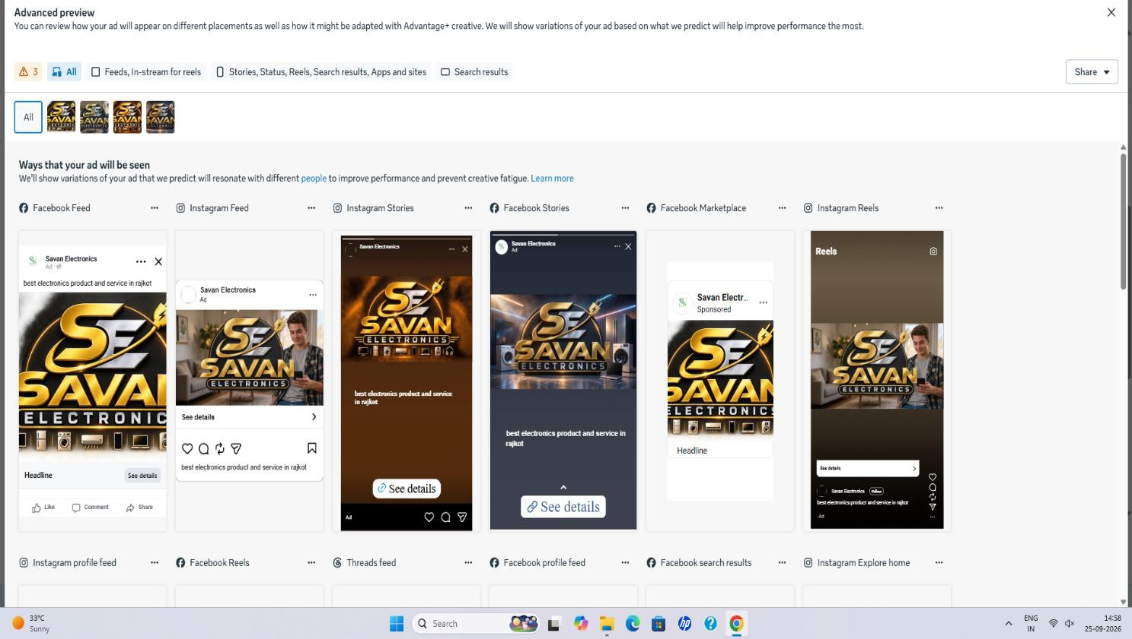
Practical 6: Meta Ads Campaign – Awareness

Practical 7: Meta Ads Campaign – Traffic
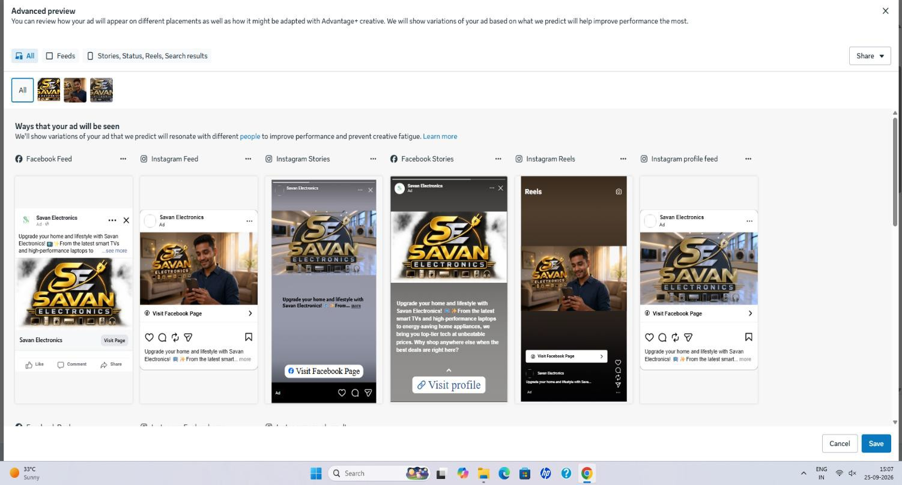
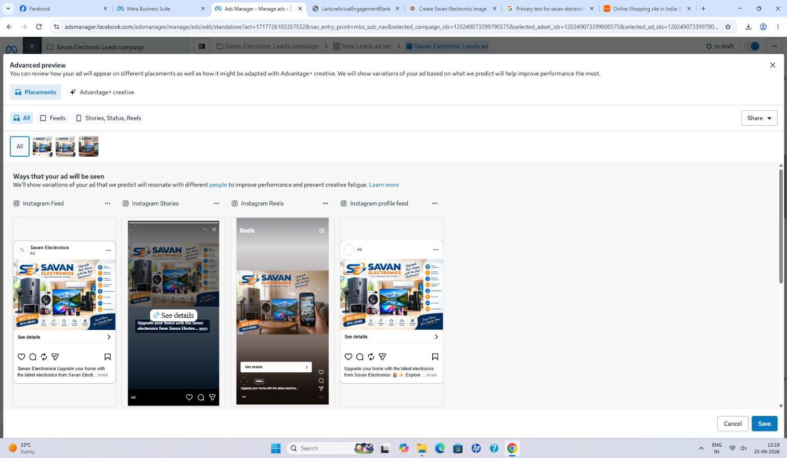
Practical 8: Meta Ads Campaign – Lead

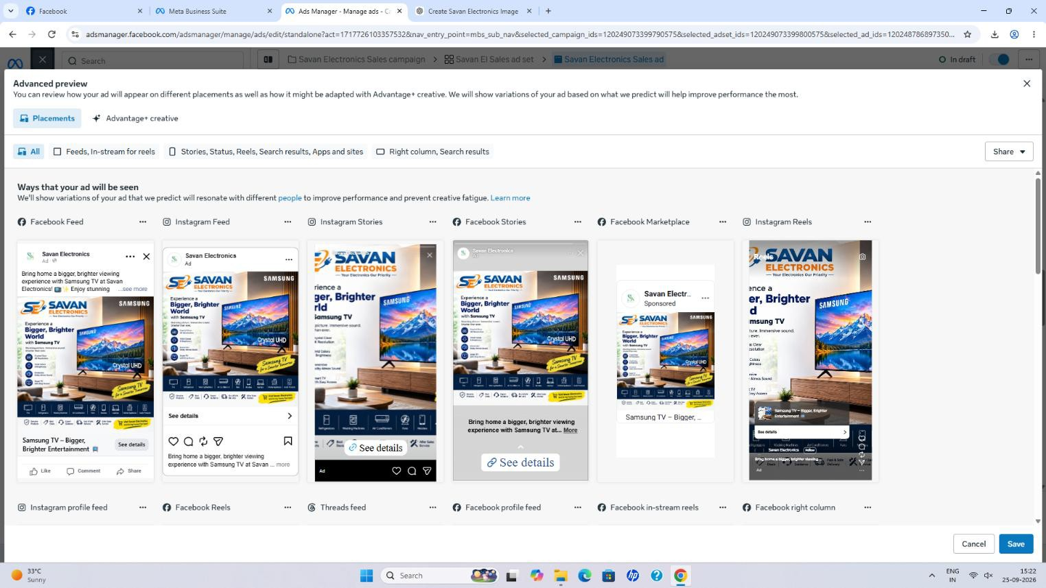
Practical 9: Meta Ads Campaign – Sales

Practical 10: Google Ads Search Campaign

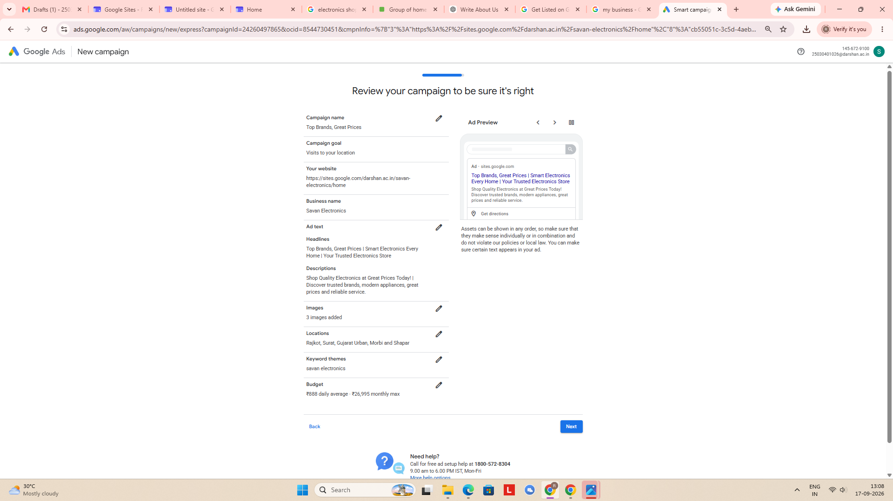

Practical 11: Google Ads – Display Campaign
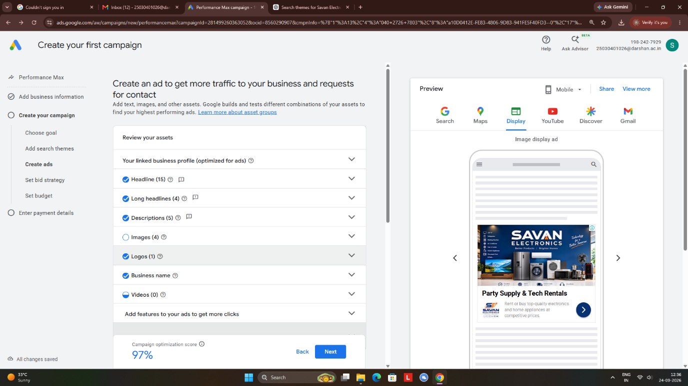

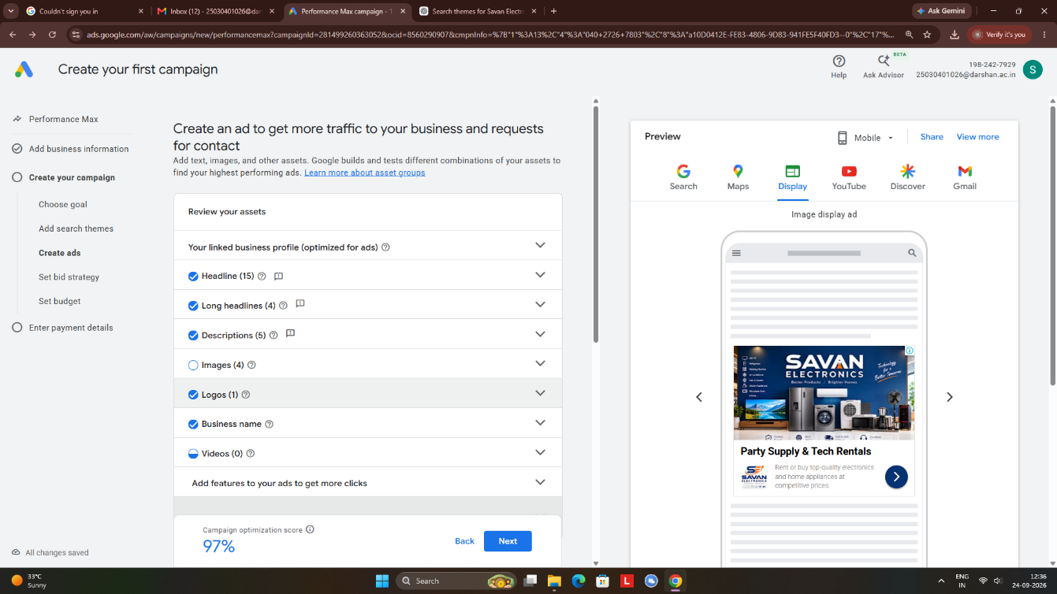

Practical 12: Google Ads – YouTube & Shopping Ads
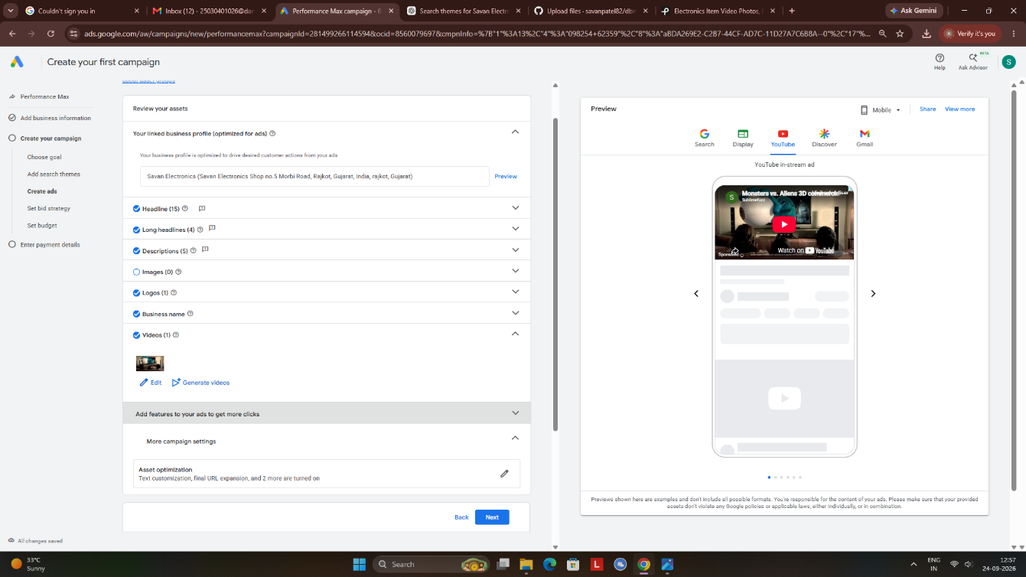

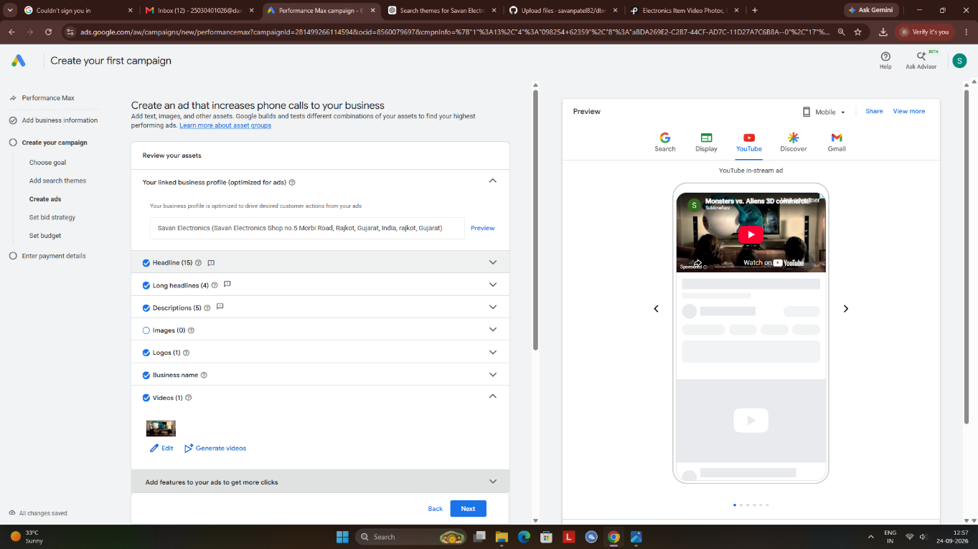

Practical 13: WhatsApp Business Setup
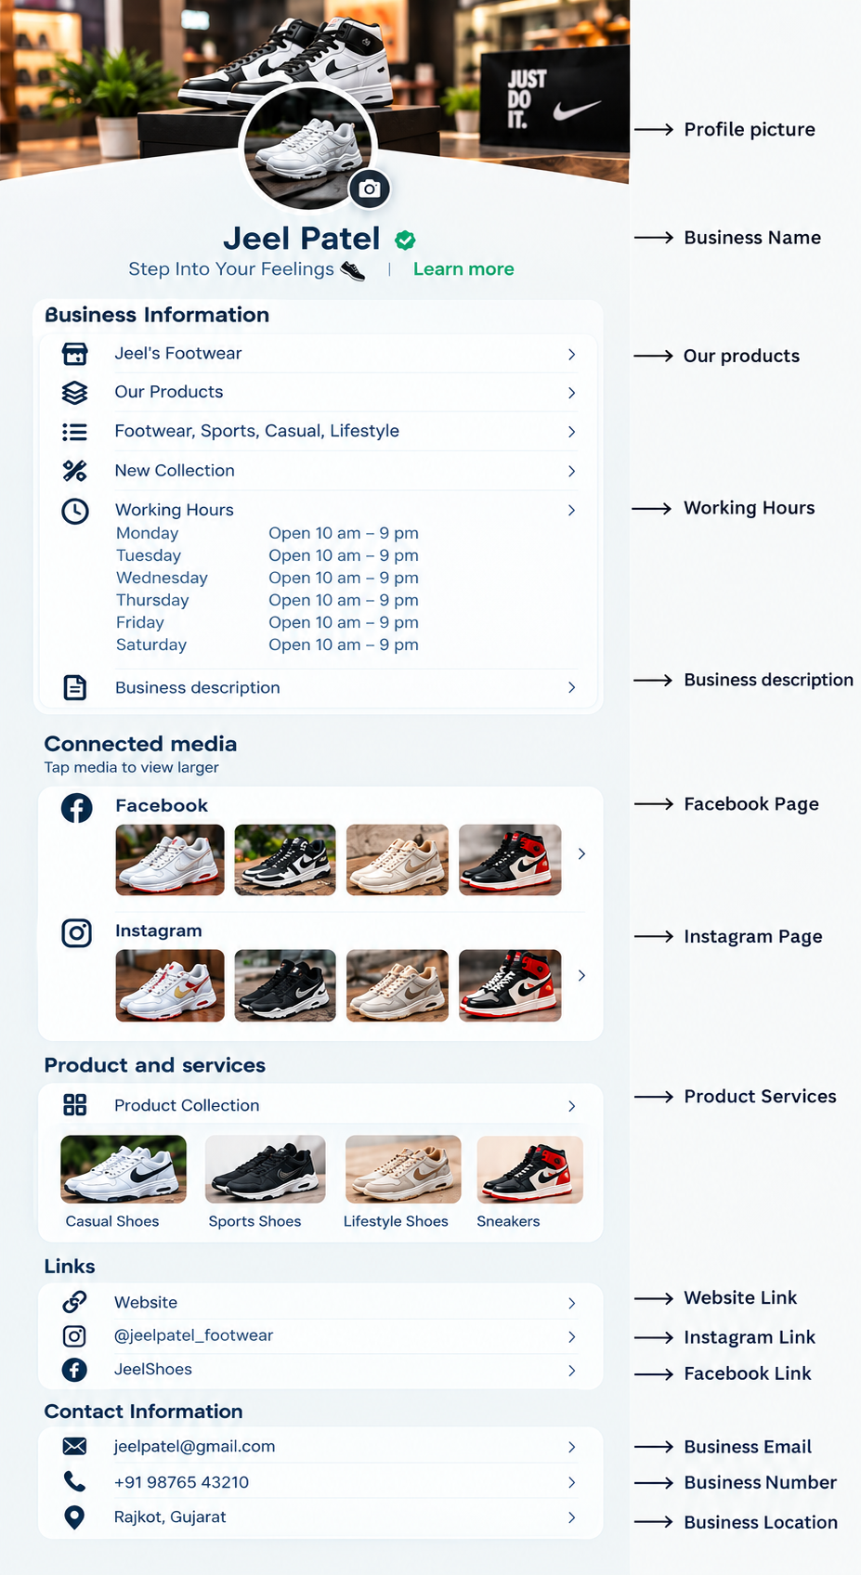

Practical 14: Email Marketing Campaign
To be inform later.

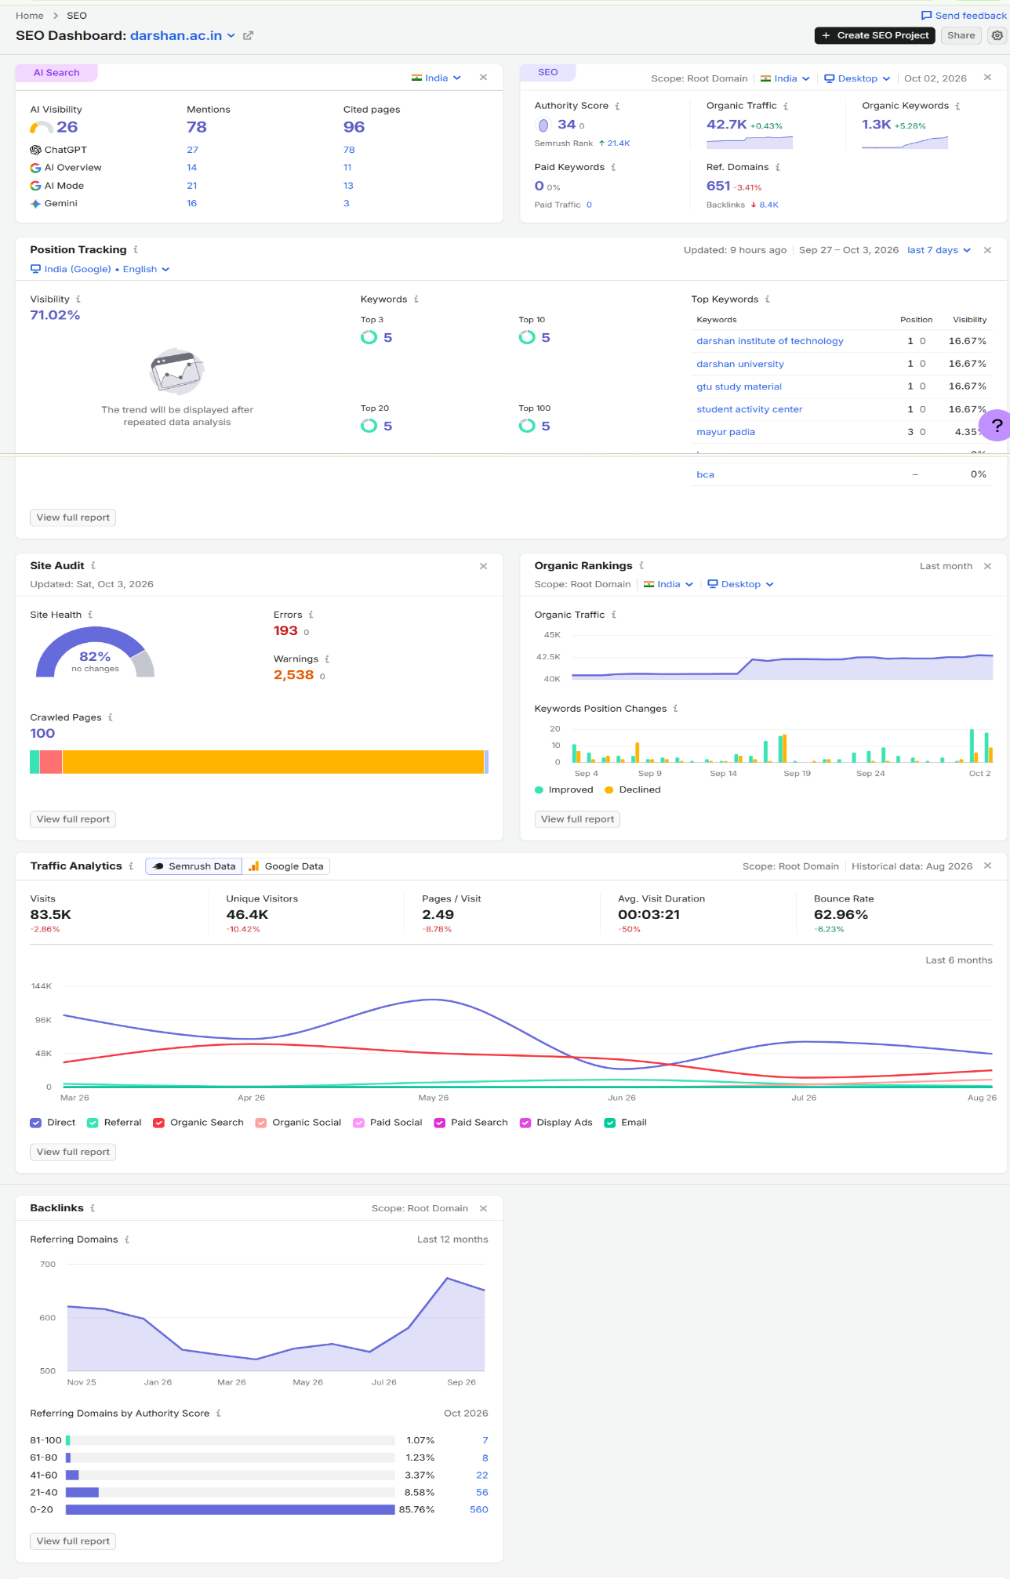
Prashant 15 SEO Tools & Keyword Researc

